**Final project report**

Subject : Panorama Registration & Stitching

Author : Netanel Davidov

**Introduction**

Image stitching is the process of combining multiple photographic images with overlapping fields of view to produce a segmented panorama or high-resolution image . We get different images that are horizontally scanning (due to camera rotation) diﬀerent parts of a scene, with signiﬁcant overlap in the ﬁeld of view of consecutive frames.

The solution is to perform automatic panorama generation - automatically stitch together different images of the same scene with overlapping elements. This is done by identifying corresponding points and then calculating the homographies for stitching the images together. It is assumed that the input images are actually overlapping photographs of the same scene, so that a panorama is actually possible.

Approach - The input of such an algorithm is a sequence of images horizontally scanning (due to camera rotation) diﬀerent parts of a scene, with signiﬁcant overlap in the ﬁeld of view of consecutive frames. The output is then a large ﬁeld of view image of the scene in which all these input images have been combined.

For image stitching, we have the following major steps to follow :

1. Compute the keypoints and descriptors for the images and find all possible matches.
2. Run RANSAC to estimate homography
3. Transform the homographies
4. Stitch all images together
5. Render RGB panorama image

**Approach and Method**

**Let's explain the steps mentioned above :**

1. **Compute the keypoints and descriptors for the images and find all possible matches –**

This step detecting and matching descriptors between each pair of images eventually**.** Ifound the key points and their descriptors with the **ORB** detector, and then I use OpenCV **Brute Force(BF)** for matching between two set of descriptors obtained from the algorithm, each set belongs to the respective image.

See: <https://pythonprogramming.net/feature-matching-homography-python-opencv-tutorial/>

Problem : One of the main problems with this algorithm is the existence of **outlier** matches and in quite large quantities between pair of images therefore we can't compute the homography matrix yet.

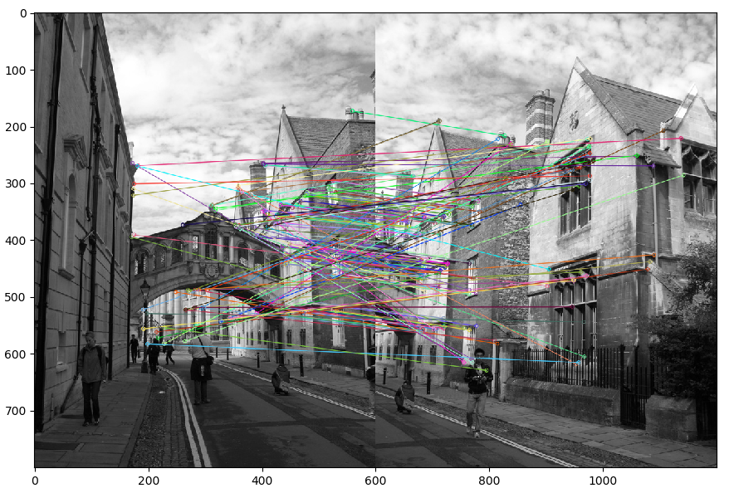

Solution* : We deal with this problem on the next step.

1. **Run RANSAC to estimate homography -**

We will now use the feature point matches found above to compute the **most ﬁtting homography** that

transforms between the two frames Ii and Ii+1.

One of the limitations of this step is the existence of a small amount of matching points between images so we get a small amount of inlier (if any). This limitation can happen due to a little overlap between a pair of images.

To calculate the homography matrix, at least 4 matching points (high accuracy) between a pair of images are required, and this set of points is called **inliers**. Now all that's left is to find the homography matrix by DLT algorithm:

* computing the A matrix by-

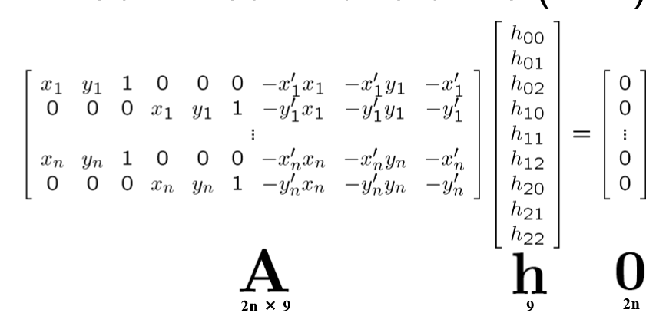

* Running the SVD algorithm on A.
* The unit singular vector corresponding to the smallest singular value is the solution h. Speciﬁcally, if A = UDV^T with D diagonal with positive diagonal entries, arranged in descending order down the diagonal, then **H** is the last column of V reshape it and H = H/H[2,2].

But not before we find:

Find inliers - The goal is to find the largest set of points inliers. This set contains matching points indexes between a pair of images. These indexes came from the function that performs a matching point between image I and image I + 1.

To define what is a good match of points we use the E price function, this function gets one point and determines whether the fit set for that point in the second picture is the best. The price function is determined by Squared Euclidean Distance as follows:

E_p = || P '- P || ^ 2 <inlierTol (We determine what it is inlierTol - inlier tolerance threshold ).

The algorithm works as follows:

Take 4 random points in picture 1, take the appropriate points in picture 2, find their transformation (H), look for the largest set that meets conditions of the price function( E ) use ApplayHomography to test if the matching points its actually like in pos2(set of OpenCV matching points), in each iteration we will save the largest set of inliers and if the next iterations found a larger set of matches It is determined to be the set of **inliers** we do this for a specified number of iterations.

Find most ﬁtting homography - Finally after finding the maximum and best set of inliers, we have the estimated points as the best and best fit between the pictures. Now it is possible to calculate the appropriate homographic matrix between the two images by leastSquareHomograpy function , hereinafter: the Solution*.

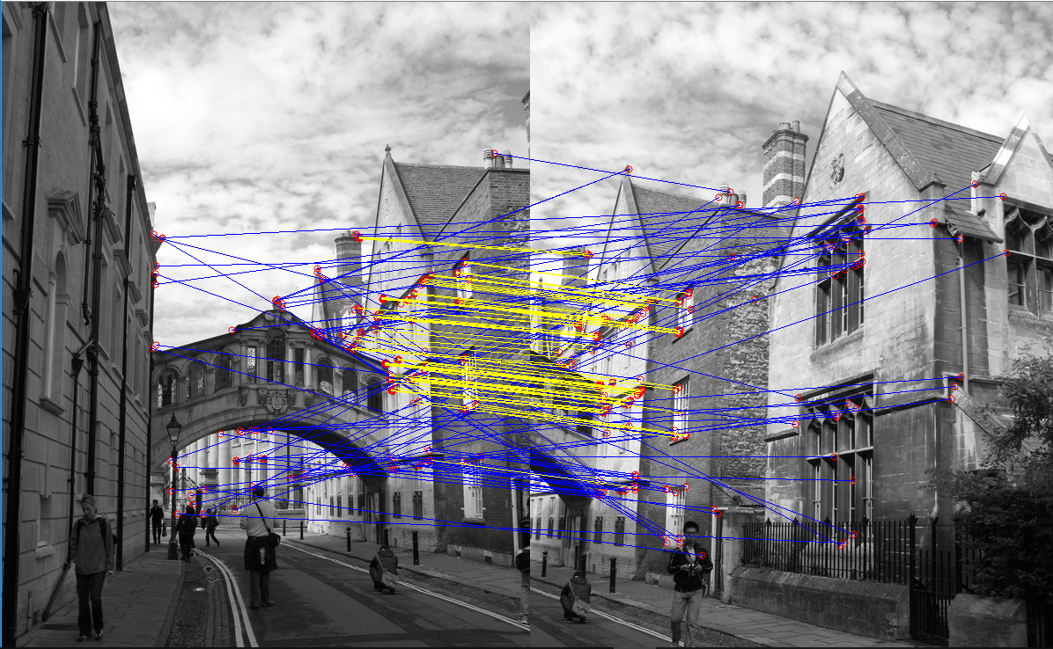

Yellow line = inlier match

Blue line = outlier match

1. **Transform the homographies –**

The goal of this step is to transforming the images to a common coordinate system .

The ﬁrst stage in doing this is to pick a coordinate system in which we would like the panorama to be rendered. We will (somewhat arbitrarily) choose this coordinate system to be the coordinate system of the middle frame Im in our image sequence, where m = ceil(M/2). What we mean by this is that the resulting panorama image will be composed of frame Im with all the other frames backwarped so that they properly align with it.

It is worth getting a conversion of all images with respect to the middle image should be transformed not from: Ii to: Ii + 1 but from: I to: Im.

Therefore, you need to convert from the Hi, i + 1 matrix group to the Hi, m matrix that converts from I coordinate to Im coordinate.

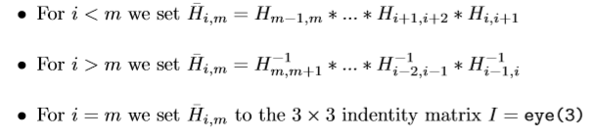

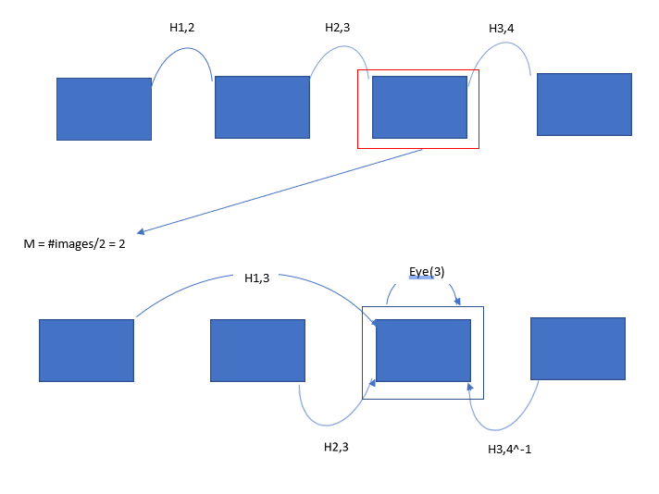

Therefore, for each image i, its matrix H which converts the coordinates of the image i into the coordinates of the selected image m is considered(H[m] = eye(i)).

1. **Stitch all images together –**

Define Ipano (Big enough empty picture), calculate the four corners of each image i and find the : xmax, xmin, ymax, ymin to define the panorama border by transform the corners to panorama coordinates and find the x,y range, find centers and strips .

Warp the images to panorama coordinates by H set of homography matrices and start to find all part from each image and backwarped all coordinates from its parts to Ii coordinates, take the intensity of the pixel (the pixel that are not black- the image is in gray scale than the same result achieved) and copy the pixel in warping to panorama coordinates in the right position.

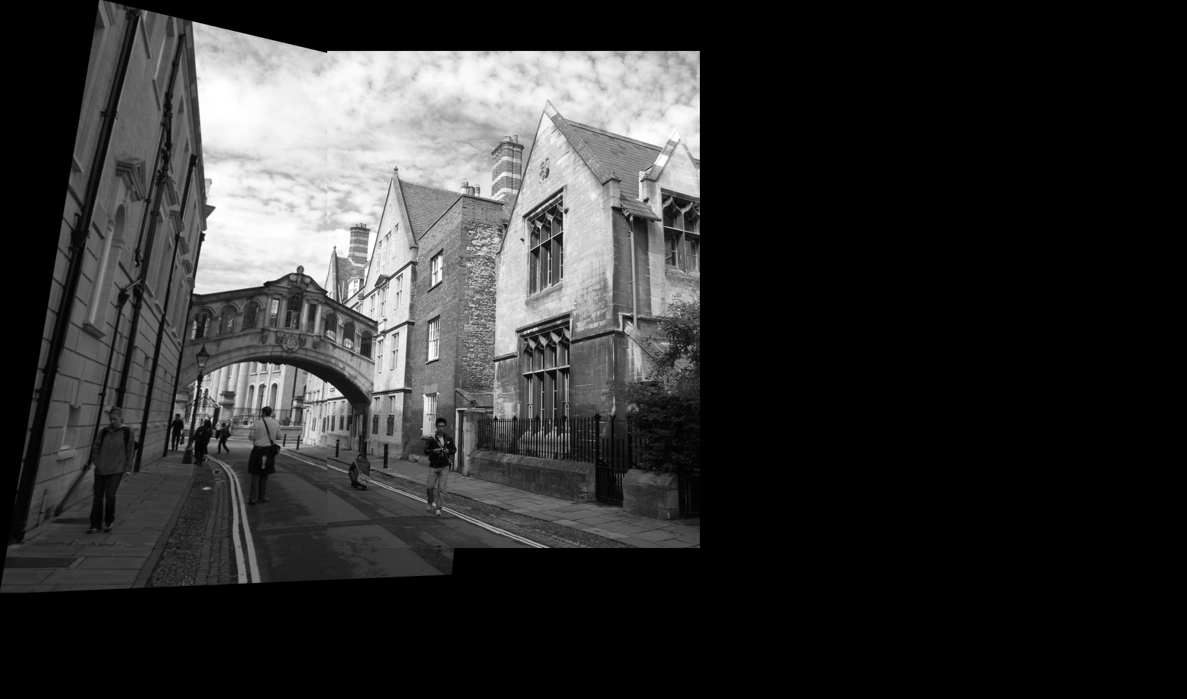

This result is due to the fact that we performed warpPerspective for each image by its corresponding H[i] matrix, this matrix is designed to convert image i coordinates to the panorama image coordinates so for each result of warpPerspective we get the corresponding position of the image in the panorama coordinates. All that's left is to find every part of the panorama and perform the steps of black warping as described above.

1. **Render RGB panorama image –**

Compute the same methods for R, G, B matrices and finally union all together to one color image.

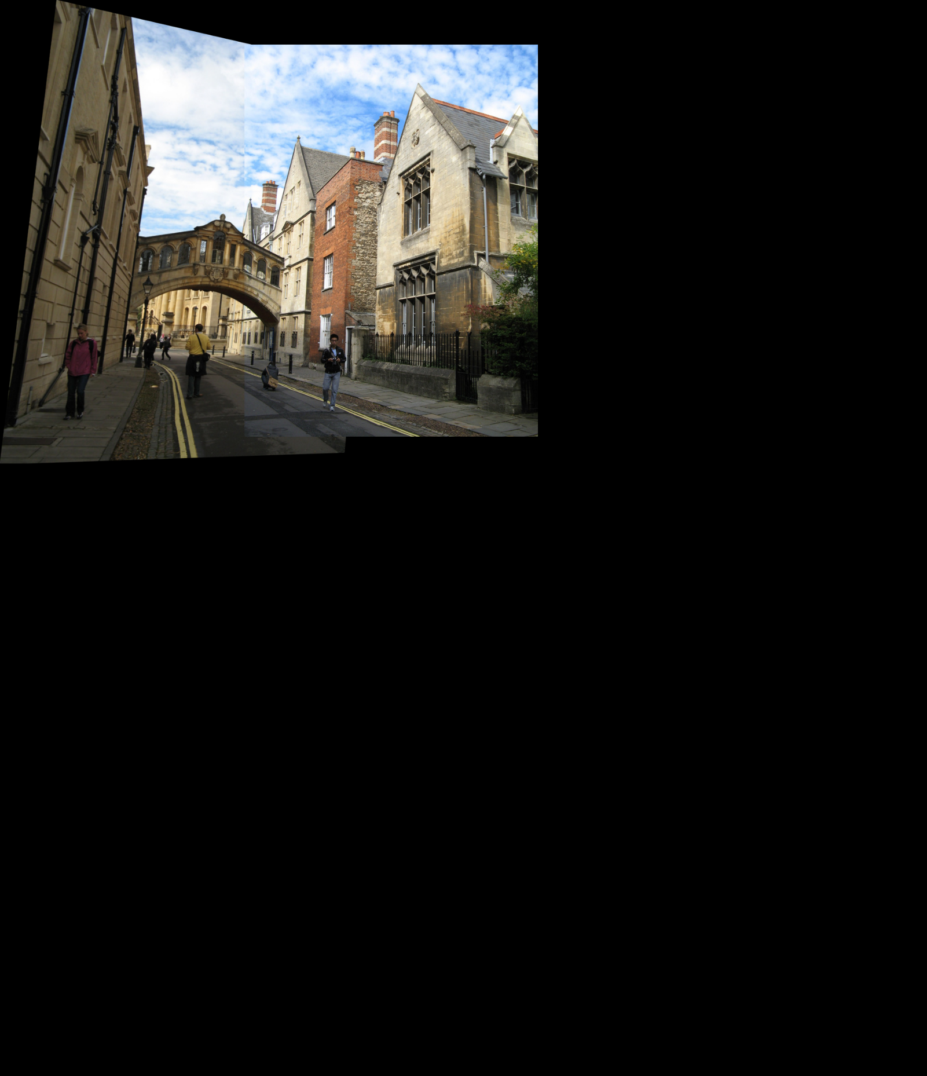

**Results**

* Test the correctness of the matches –

Images - 'data/inp/examples/backyard1.jpg', 'data/inp/examples/backyard2.jpg'

Number of iteration = 170

Inlier threshold = 5

Before finding inliers and outliers:

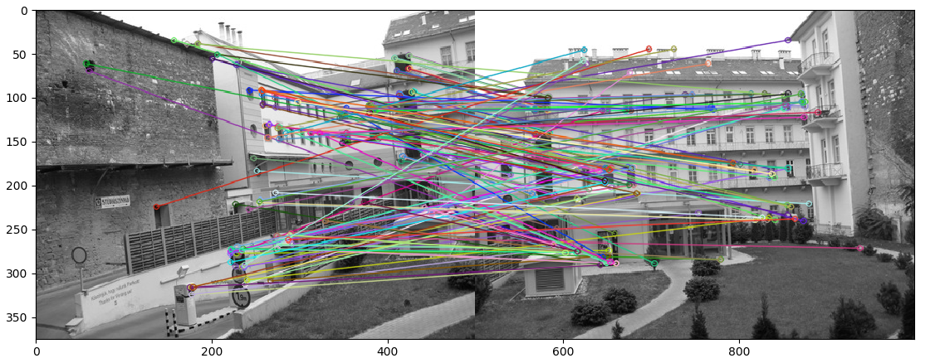

After:

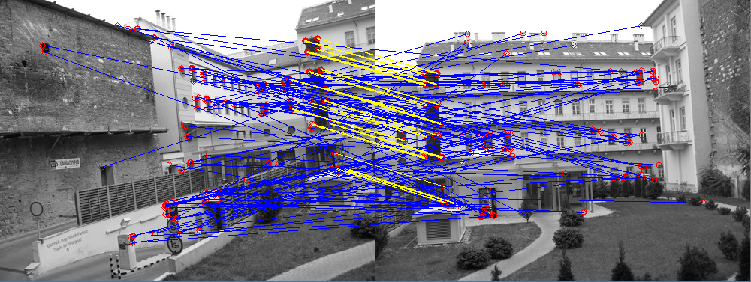

I have run the "testTheInliers" test function to check the correctness of the finding inliers algorithm, this is the output:

Pixels in image 2

Pixels in image 1

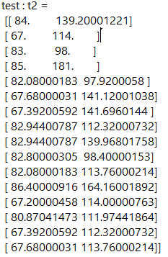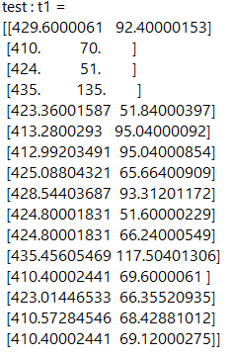

The **conclusion** is that the algorithm is able to find the matching points well between the images for the reason that it was able to find the appropriate points even by selecting neighboring pixels well (single pixels distance).

* Test the effect of the number of iterations -

We now want to examine the effect of the number of iterations that the RANSAC algorithm has on the quantity and quality of inliers.

Images - 'data/inp/examples/oxford1.jpg', 'data/inp/examples/oxford2.jpg'

Number of iteration = 200

Inlier threshold = 5

Amount inliers = 88

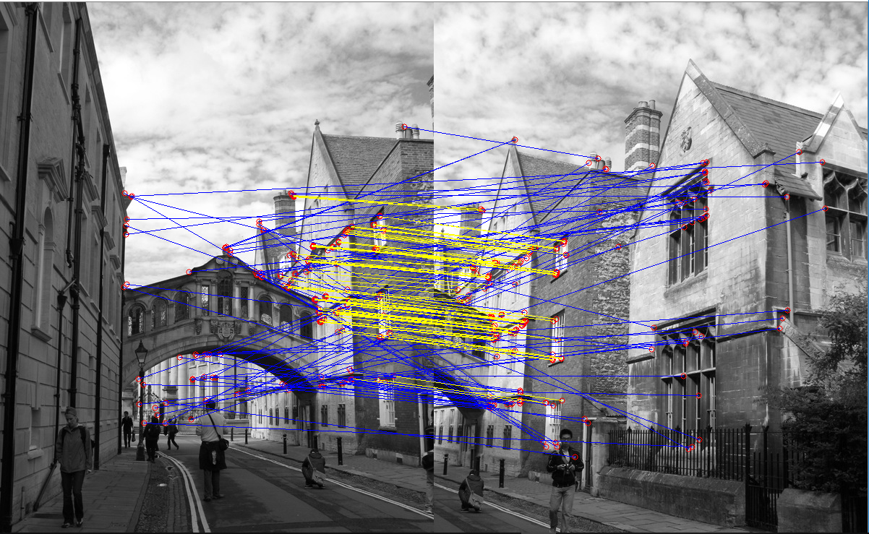

Number of iteration = 80

Inlier threshold = 5

Amount inliers = 104

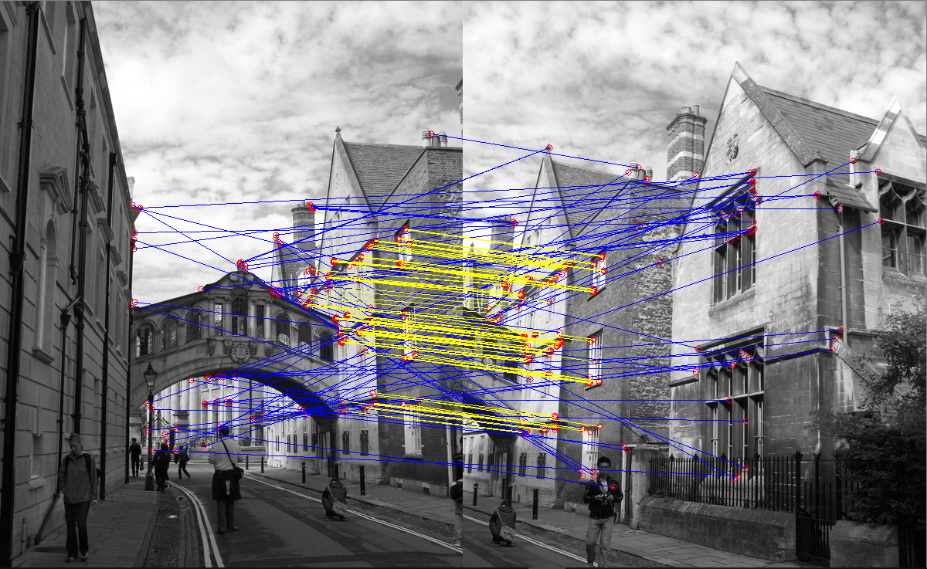

Number of iteration = 30

Inlier threshold = 5

Amount inliers = 93

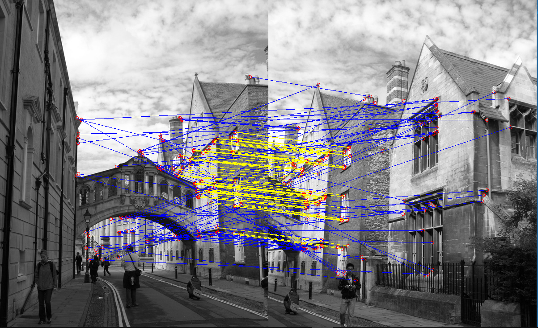

Number of iteration = 4

Inlier threshold = 5

Amount inliers = 18

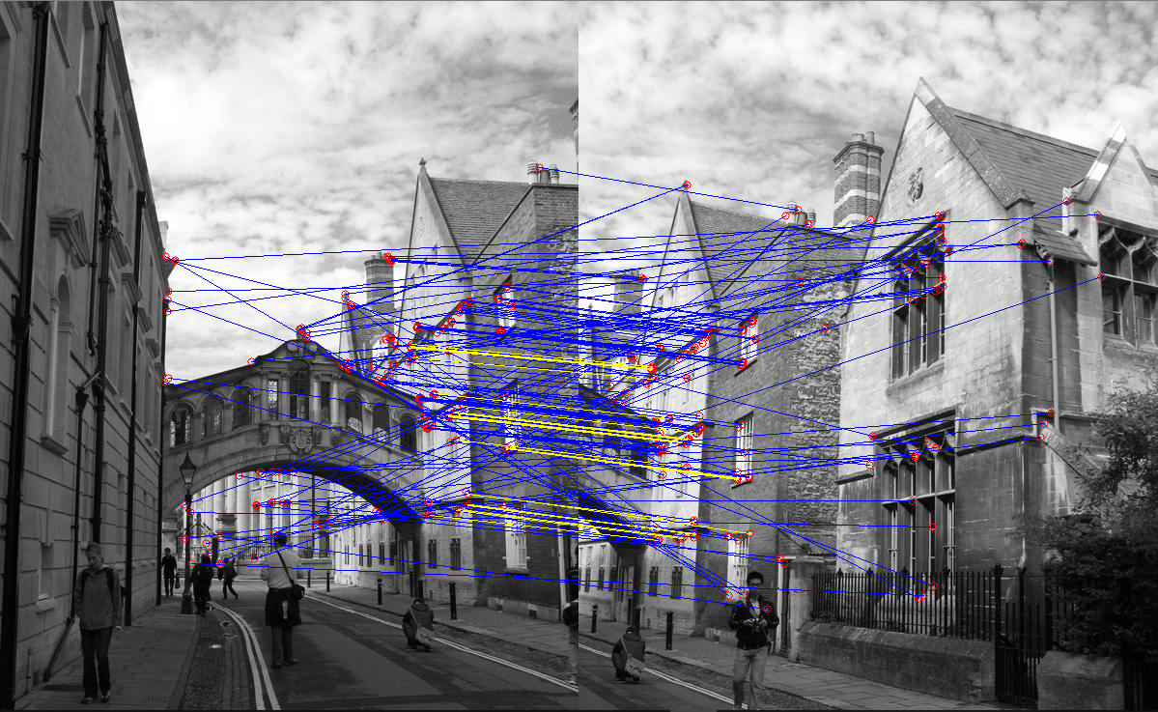

The **conclusion** I have reached is that there is not necessarily a relationship between the number of iterations and the number of inliers when passing a certain threshold of several iterations is called **n**. Since I wish that iterations closest to the maximum set of inliers were already selected and any additional iterations would usually be of no use.

But when the number of iterations is very low (much smaller than n) we get a small number of inliers because the algorithm did not take enough random point samples to estimate what is the best homography matrix that results in the maximum number of inliers.

* Test the effect of inliers threshold –

We want to test the effect of inlier tolerance threshold on the amount and quality of inliers we receive.

Images - 'data/inp/examples/ backyard1.jpg', 'data/inp/examples/ backyard2.jpg'

Number of iteration = 170

Inlier threshold = 1

Amount inliers = 13

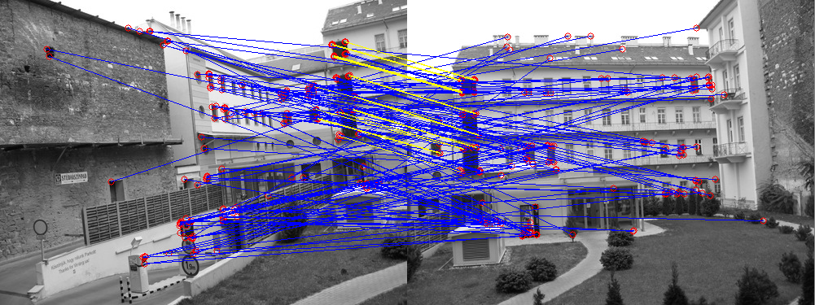

Number of iteration = 170

Inlier threshold = 10

Amount inliers = 49

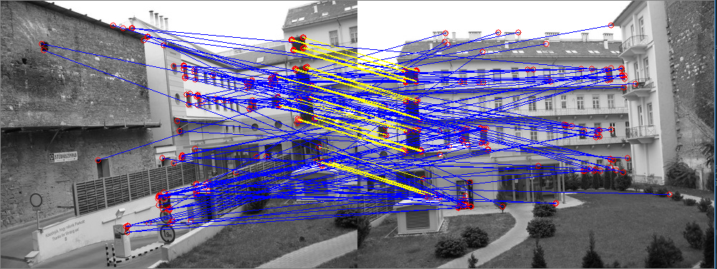

Number of iteration = 170

Inlier threshold = 20

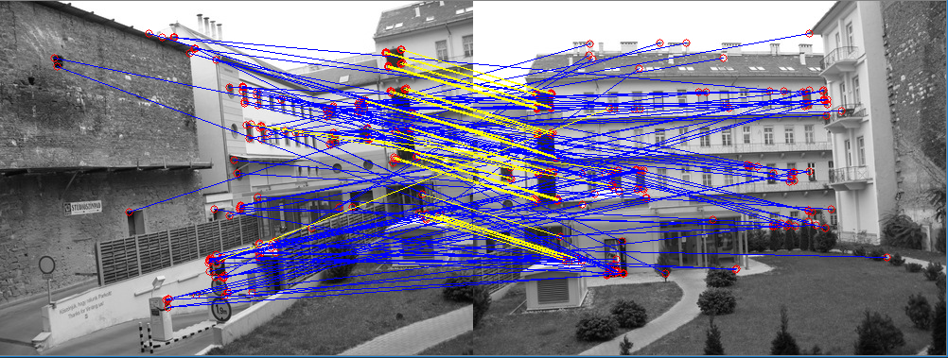Amount inliers = 57

The **conclusion** is that if you allow the inlierTool to be higher then there is a reasonable possibility that the inliers group will also enter matches that are considered outlier but because they managed to meet the terms of the price function they entered this group.

* The result of mine images –

Images :

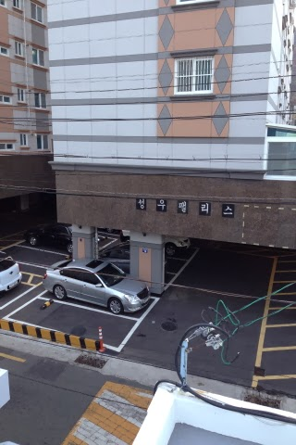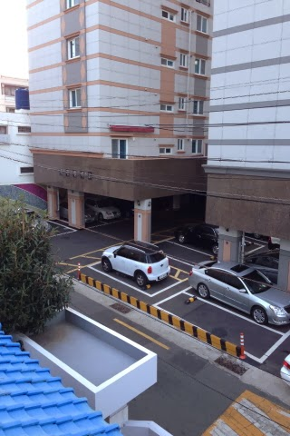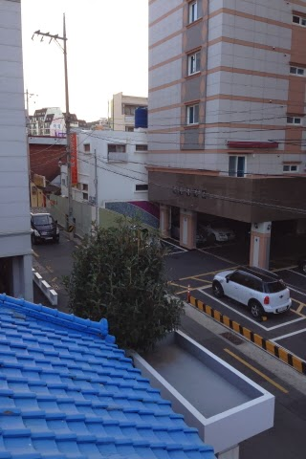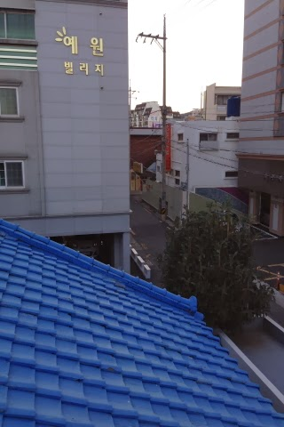

Generate panorama :

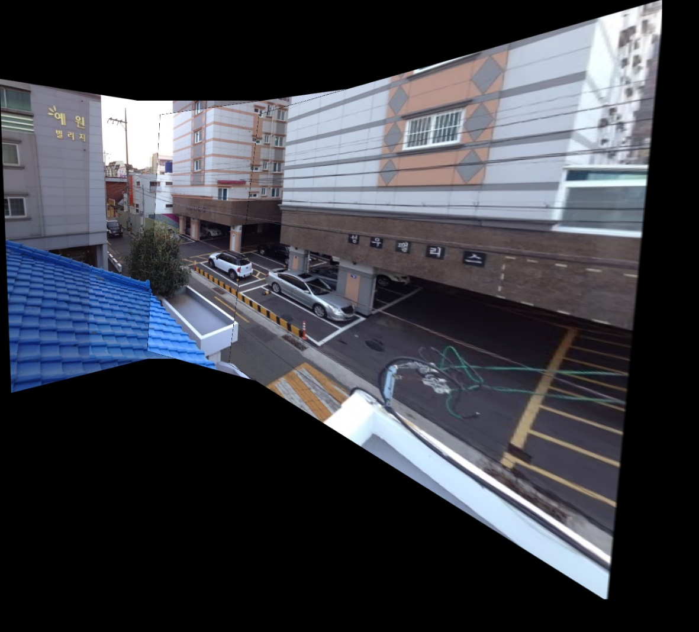

Images –

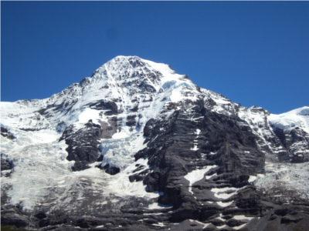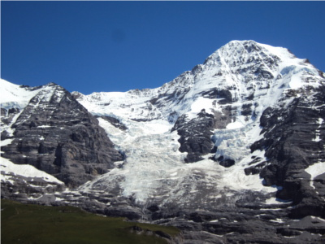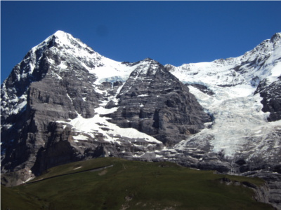

Generate panorama :

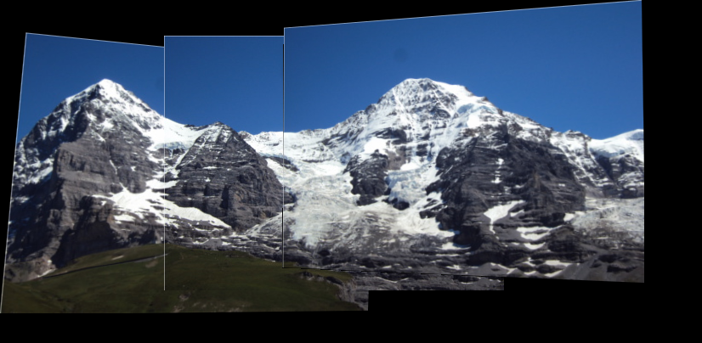

* The result of examples images –

